1. What is the total number of reservations in the dataset?

select count(Booking_ID) as Total_Reservations

from hotel_reservation_data

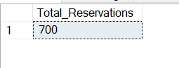

2. Which meal plan is the most popular among guests?

select type_of_meal_plan,count(type_of_meal_plan) as Popularity

from hotel_reservation_data

group by type_of_meal_plan

order by count(type_of_meal_plan) desc

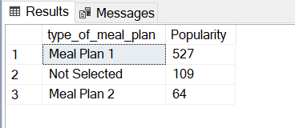

3. What is the average price per room for reservations involving children?

select avg(cast(avg_price_per_room as decimal(10,2))) as Average_price

from hotel_reservation_data

where no_of_children>0

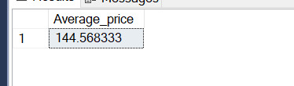

4. How many reservations were made for the year 20XX (replace XX with the desired year)?

select COUNT(Booking_ID) as Reservation_Year

from hotel_reservation_data

where year(arrival_date)=2018

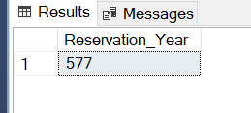

5. What is the most commonly booked room type?

select room_type_reserved,count(room_type_reserved) as no_of_reservation

from hotel_reservation_data

group by room_type_reserved

order by count(room_type_reserved) desc

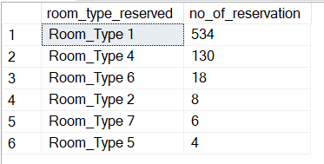

6. How many reservations fall on a weekend (no_of_weekend_nights > 0)?

select Count(Booking_ID) as Weekend_Reservation

from hotel_reservation_data

where no_of_weekend_nights>0

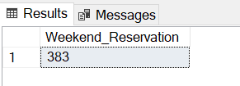

7. What is the highest and lowest lead time for reservations?

select max(lead_time) as Highest_lead_time ,min(lead_time) as Lowest_lead_time

from hotel_reservation_data

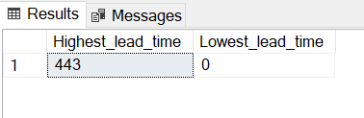

8. What is the most common market segment type for reservations?

select market_segment_type,count(market_segment_type) as no_of_reservation

from hotel_reservation_data

group by market_segment_type

order by count(market_segment_type) desc

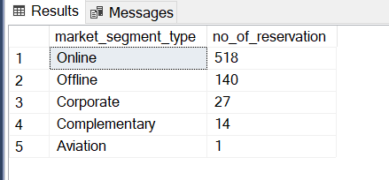

9. How many reservations have a booking status of "Confirmed"?

select count(Booking_ID) as Confirmed_booking

from hotel_reservation_data

where booking_status='Not_Canceled'

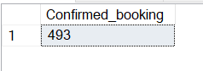

10. What is the total number of adults and children across all reservations?

select sum(no_of_adults) as Total_Adults, sum(no_of_children) as Total_Children

from hotel_reservation_data

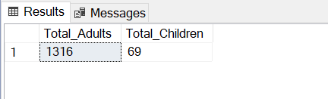

11. What is the average number of weekend nights for reservations involving children?

select avg(cast(no_of_weekend_nights as decimal(10,2))) as Avg_no_of_Weekend_night

from hotel_reservation_data

where no_of_children>0

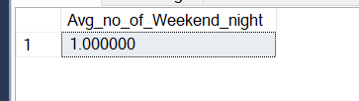

12. How many reservations were made in each month of the year?

select datename(month,arrival_date) as Months ,count(datename(month,arrival_date)) as no_of_reservations

from hotel_reservation_data

group by datename(month,arrival_date),DATEPART(mm, arrival_date)

order by DATEPART(mm, arrival_date)

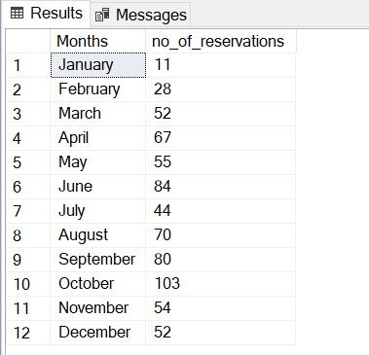

13. What is the average number of nights (both weekend and weekday) spent by guests for each room type?

select room_type_reserved, avg(cast(no_of_week_nights+no_of_weekend_nights as decimal(10,2))) as Average_Nights

from hotel_reservation_data

group by room_type_reserved

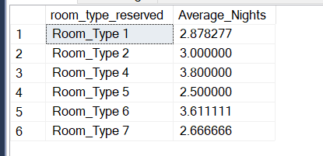

14. For reservations involving children, what is the most common room type, and what is the average price for that room type?

select room_type_reserved,count(Booking_ID) as Bookings_with_children,avg(avg_price_per_room)as Average_Price

from hotel_reservation_data

where no_of_children>0

group by room_type_reserved 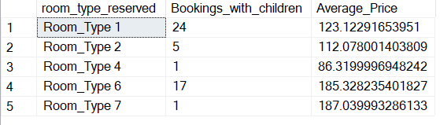

15. Find the market segment type that generates the highest average price per room.

select market_segment_type,avg(cast(avg_price_per_room as decimal(10,2))) as Average_Price

from hotel_reservation_data

group by market_segment_type

order by avg(avg_price_per_room) desc

